1. **How to compare two JSON have the same properties without order?**
2. **Let obj1 = { name:”Person1”,age:”5”};**
3. **Let obj2 = {age:”5”,name:”Person1”};**

// Getting input via STDIN

const readline = require("readline");

const inp = readline.createInterface({

input: process.stdin

});

const userInput = [];

inp.on("line", (data) => {

userInput.push(data);

});

inp.on("close", () => {

//start-here

//Your code goes here … replace the below line with your code logic

var isEqualsJson = (o1,o2)=>{

key1 = Object.keys(o1);

key2 = Object.keys(o2);

return key1.length === key2.length && Object.keys(o1).every(key=>o1[key]==o2[key]);

}

let obj1 = {name:"Person1",age:"5"};

let obj2 = {age:"5",name:"Person1"};

if(isEqualsJson(obj1,obj2)){

console.log("Both JSON objects are same");

}else{

console.log("JSON objects are different");

}

//end-here

});

**OUTPUT:**

Both JSON objects are same

1. Use the reset countries API URL -><https://restcountries.com/v3.1/all> and display all the countries flags in the console

const countriesRequest = new XMLHttpRequest();

// Step 2: Configuration

countriesRequest.open('GET', 'https://restcountries.com/v3.1/all/');

// Step 3: Make the Request

countriesRequest.send();

// Step 4: Get the data in Your desired format

countriesRequest.onload = function () {

  if (countriesRequest.status === 200) {

    const countries = JSON.parse(countriesRequest.responseText);

    for (var country of countries) {

      console.log(country.flag);

    }

  } else {

    console.log('Countries Not Found');

  }

}

countriesRequest.onerror = function () {

  console.log('Countries Not Found');

}

**OUTPUT:**

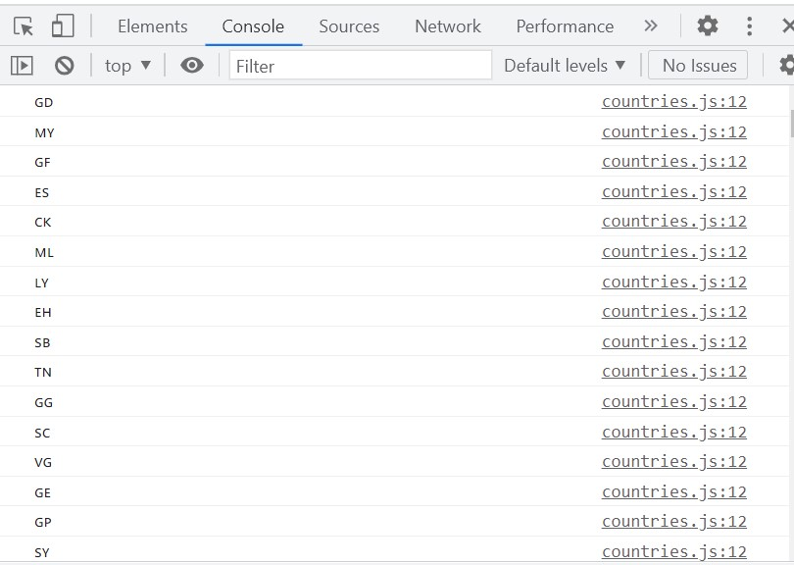

1. **Use the same rest countries and print all countries names, regions, sub-region and populations.**

const countriesRequest = new XMLHttpRequest();

// Step 2: Configuration

countriesRequest.open('GET', 'https://restcountries.com/v3.1/all/');

// Step 3: Make the Request

countriesRequest.send();

// Step 4: Get the data in Your desired format

countriesRequest.onload = function () {

  if (countriesRequest.status === 200) {

    const countries = JSON.parse(countriesRequest.responseText);

    for (var country of countries) {

      //console.log(country.population);

      console.log("Name :"+country.name.common+" Region: "+country.region+" SubRegion: "+

      country.subregion+" Population:" +country.population);

    }

  } else {

    console.log('Countries Not Found');

  }

}

countriesRequest.onerror = function () {

  console.log('Countries Not Found');

}

**OUTPUT:**

